CS 255 System Design Document Template

This template lays out all the different sections that you need to complete for Project Two. Each section has guidance to prompt your thinking. You will need to continually reference the interview transcript as you work to make sure that you are addressing your client’s needs. There is no required length for the final document. Instead the goal is to complete each section based on what your client’s needs are. Remove this note when you are finished, and replace all bracketed text with the relevant information.

UML Diagrams

UML Use Case Diagram
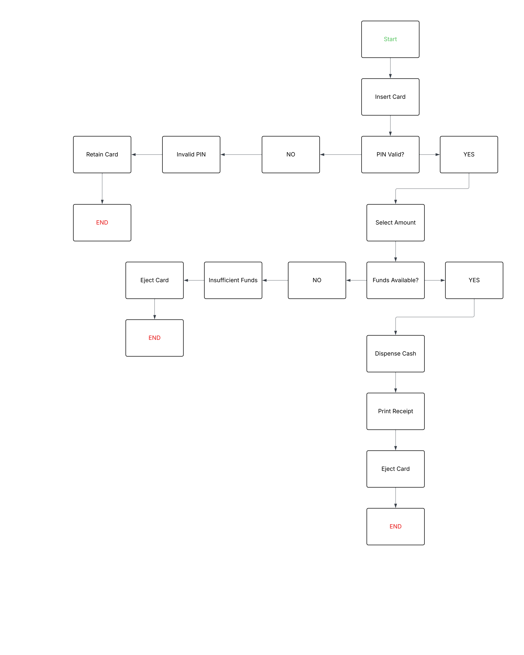

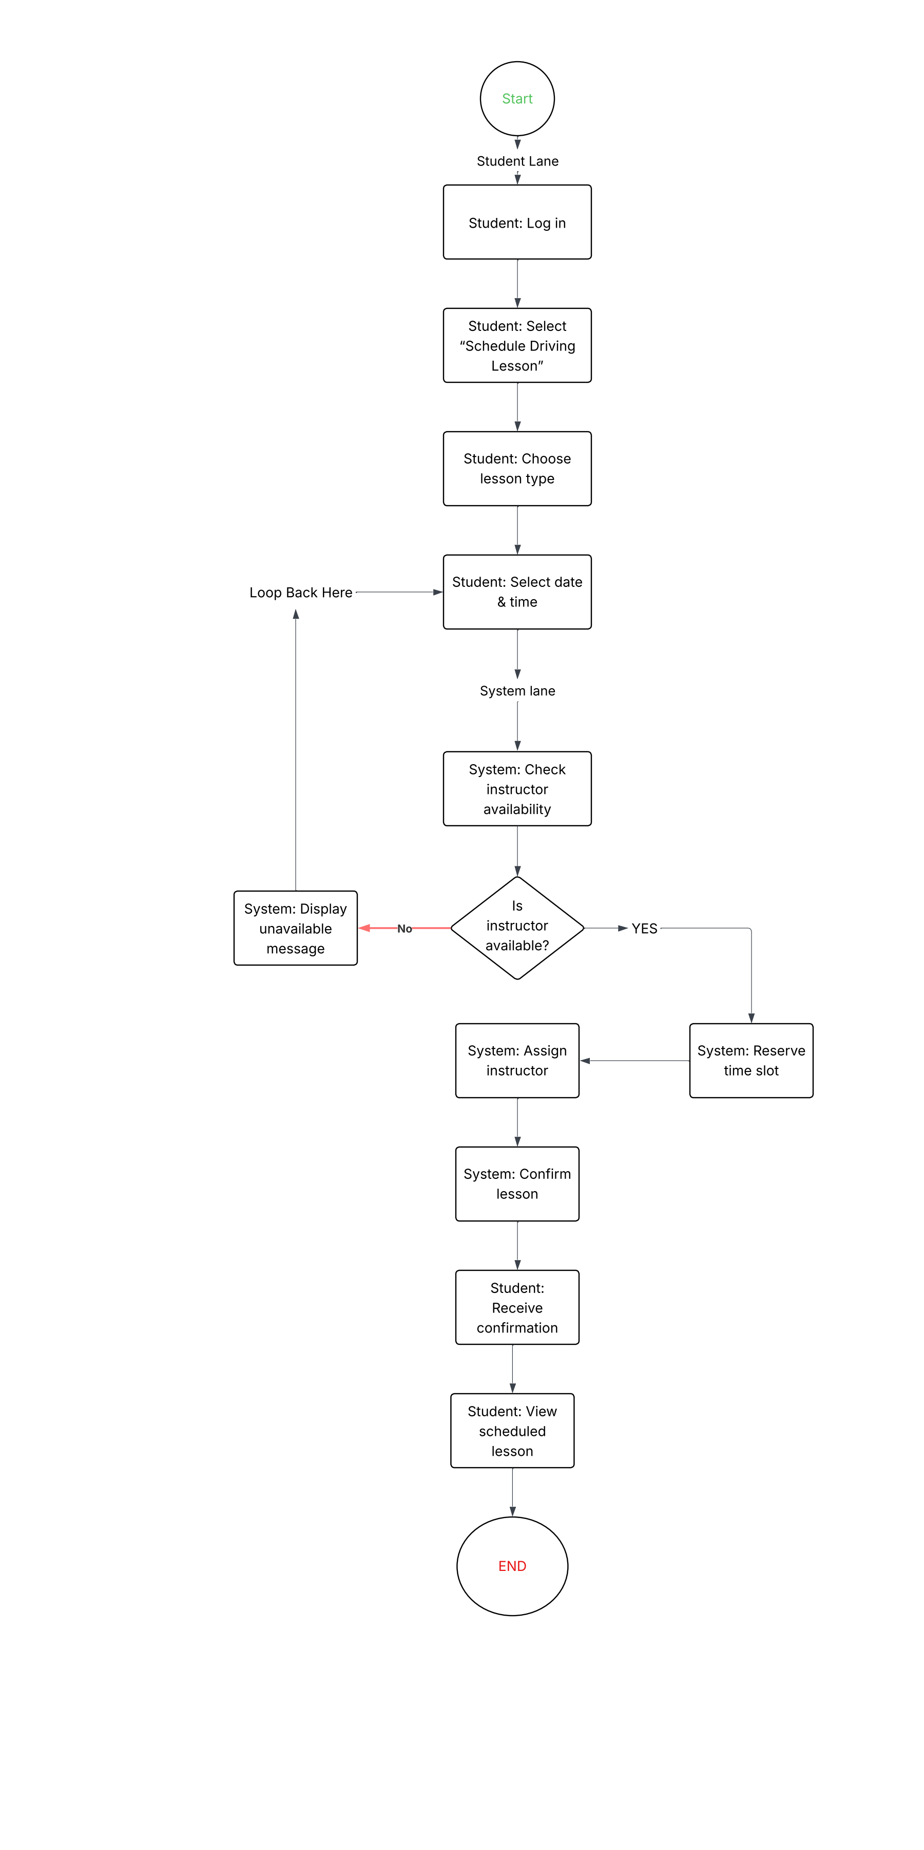
UML Activity Diagrams

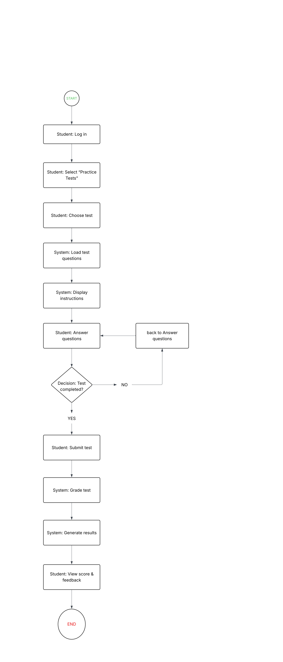

UML Sequence Diagram

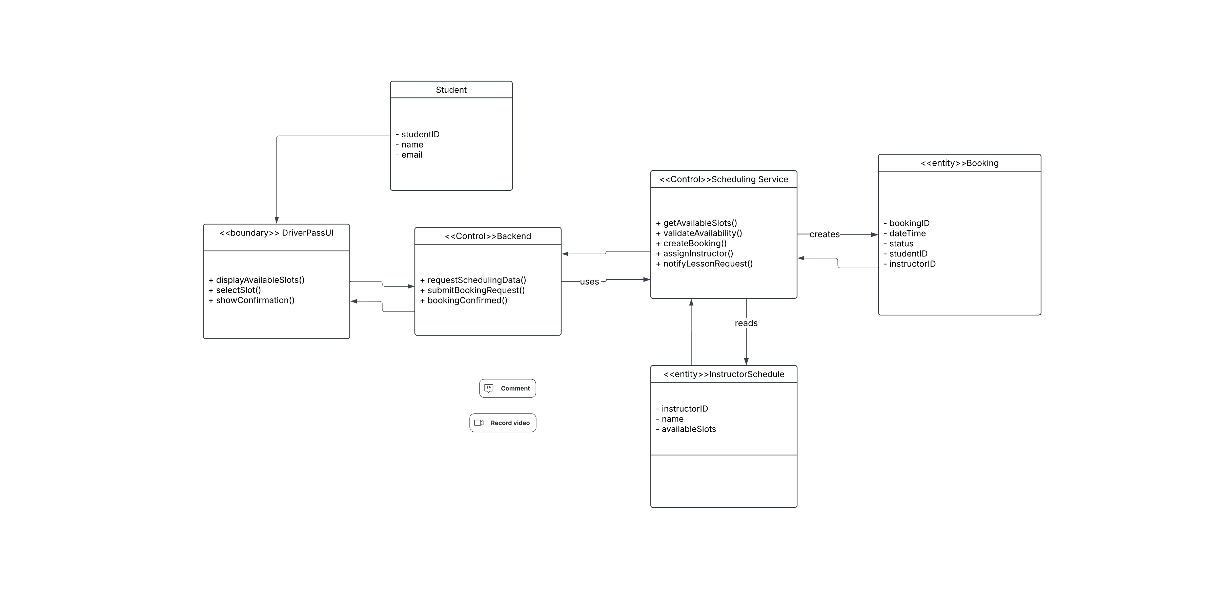

UML Class Diagram

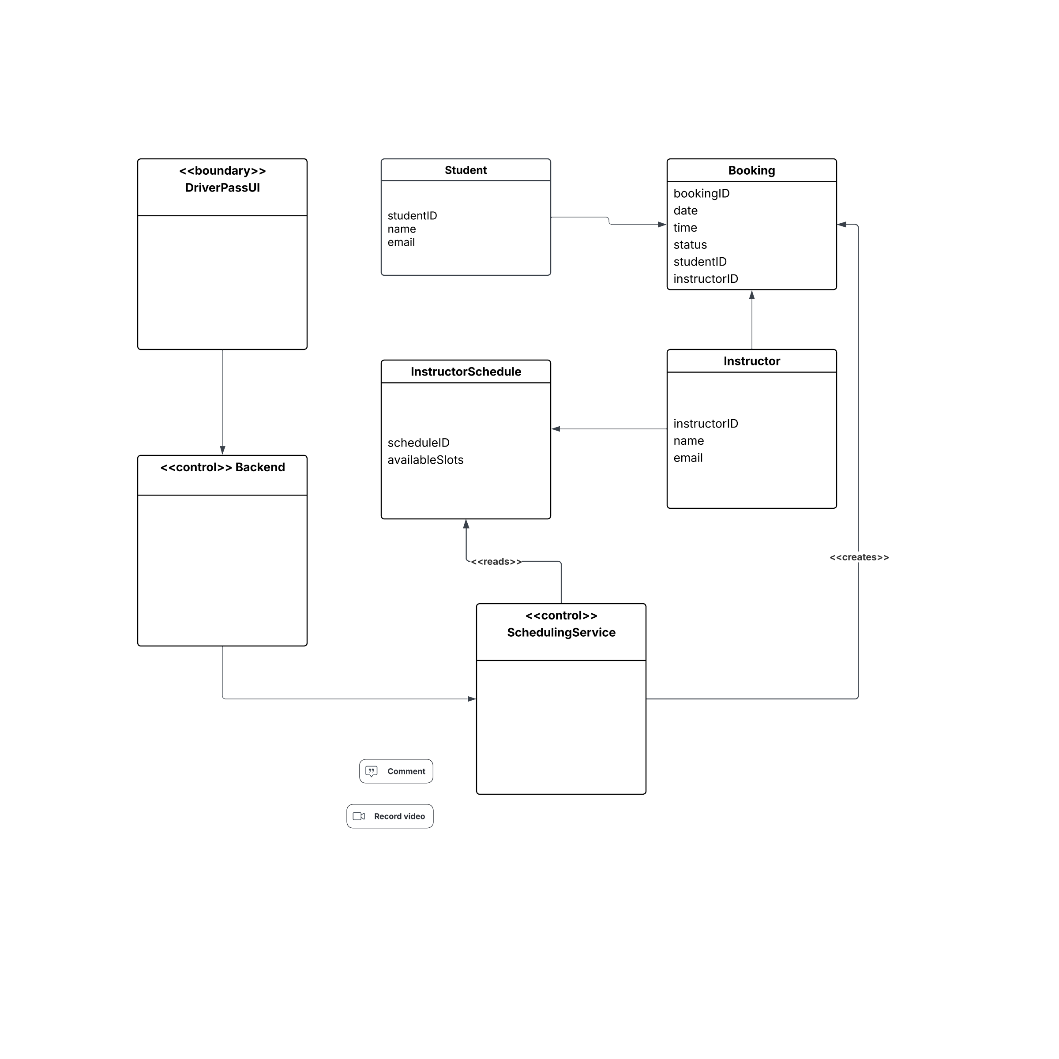

Technical Requirements

This section describes the technical needs of the DriverPass system based on the diagrams created for this project, including the activity diagrams, sequence diagrams, and class diagram. The system is designed to help students schedule driving lessons and complete online practice tests in a clear, reliable, and organized way.

Overall System Design
The DriverPass system is designed as a multi-part application where each part has a specific role. Students and instructors interact with the system through a user interface, while the system’s main logic runs behind the scenes. All important information is stored in a database so that data remains consistent and available when needed.
This structure allows the system to operate smoothly while keeping responsibilities separated, which makes the system easier to maintain and expand in the future.

Hardware Requirements
- Any device capable of running a modern web browser, such as a laptop, desktop, tablet, or smartphone
- Server hardware (cloud-based or local) to host the system and store data
- Reliable internet access to support scheduling, test submissions, and notifications
- Enough storage space to save user accounts, lesson bookings, schedules, and practice test results

Software Requirements
- A modern web browser for students and instructors to access the system
- A backend application server to process requests and manage system operations
- A database system to store all user, scheduling, and booking information
- A server operating system capable of running web and application services

System Components
DriverPass User Interface
The user interface allows students to schedule driving lessons, take practice tests, and view confirmations or results. It acts as the main point of interaction for users and sends requests to the backend for processing.
Backend System
The backend manages communication between the user interface and the rest of the system. It receives requests from users, checks that the information is valid, and forwards requests to the scheduling service when needed.
Scheduling Service
The scheduling service handles all lesson scheduling logic. It checks instructor availability, confirms time slots, creates bookings, assigns instructors, and updates booking status once a lesson is confirmed.
Database
The database stores all important system data, including student information, instructor information, lesson schedules, and booking records. This ensures that information remains accurate and available across the system.

Data Requirements
The system uses several main data types to support scheduling and testing features:
- Student information such as ID, name, and email
- Instructor information including ID, name, and email
- Instructor Schedule data that lists available lesson time slots
- Booking records that store lesson date, time, status, student, and instructor
Each booking connects one student with one instructor and is created only after the system verifies that the selected time slot is available.

Support for System Functions
The system is designed to support the following key actions:
- Students can view available lesson times
- Students can schedule and confirm driving lessons
- The system checks instructor availability before confirming a lesson
- Instructors are notified when a lesson is scheduled
- Students can take practice tests and submit answers
- The system grades practice tests and displays results to students
These functions ensure that both scheduling and testing processes are handled accurately and efficiently.

Security Considerations
- Users must be logged in to access scheduling and testing features
- The system prevents direct access to stored data from the user interface
- Student and instructor information is protected from unauthorized access
- Lesson bookings and test submissions are checked to prevent errors or conflicts

Tools and Infrastructure
- UML diagrams were created using Lucidchart to visualize system behavior and structure
- Documentation is created using a word processing tool
- The system is designed to run on scalable server infrastructure to support multiple users at the same time

Summary
The DriverPass system is designed to provide a clear and dependable way for students to schedule driving lessons and complete practice tests. By separating responsibilities across system components and storing information in a central database, the system supports reliable operation, data accuracy, and future growth. The technical design directly reflects the UML diagrams created for this project and meets the functional needs identified in earlier project stages.

